|  |  |
| --- | --- |
| **EX.NO. 4** | **INSTALLATION OF APACHE TOMCAT WEBSERVER** |
| **DATE: 13.09.2021** |  |

**AIM**

To install Apache Tomcat web server

# PROCEDURE

1. Download Tomcat 8.0 at https://tomcat.apache.org/download-80.cgi#8.0.47. Select the 64-bit version for Windows:

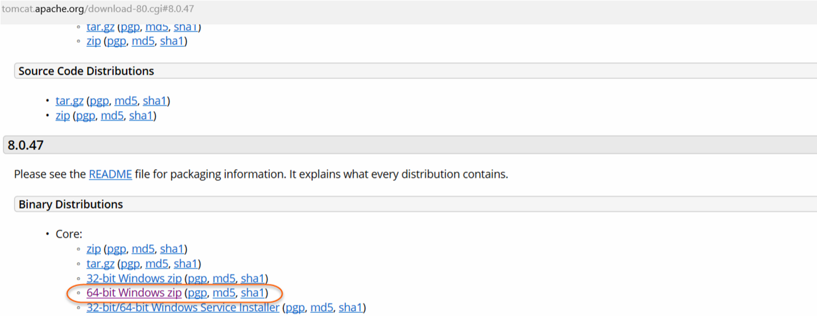

1. Extract the zip file to a directory on your computer, e.g., c:/Tomcat8.
2. To configure Tomcat, you may define CATALINA_HOME and CATALINA_BASE environment variables in the Windows Control Panel, although this will not be required for starting and stopping Tomcat from the command line. Set the value of each environment variable to the install directory in the previous step, e.g., c:/Tomcat8.
3. While in the Control Panel environment variables definition panel, add the bin directory of Tomcat to the PATH variable. The bin directory is located in the install directory, e.g., c:/Tomcat8/bin.
4. Tomcat installation and initial configuration is complete.

# CONCEPTS INVOLVED

* Apache Tomcat (called "Tomcat" for short) is a free and open-source implementation of the Jakarta Servlet, Jakarta Expression Language, Jakarta Expression Language and WebSocket technologies. Tomcat provides a "pure Java" HTTP web server environment in which Java code can run.
* Tomcat is developed and maintained by an open community of developers under the auspices of the Apache Software Foundation, released under the Apache License 2.0 license.
* Catalina is Tomcat's servlet container. Catalina implements Sun Microsystems' specifications for servlet and JavaServer Pages (JSP). In Tomcat, a Realm element represents a "database" of usernames, passwords, and roles (similar to Unix groups) assigned to those users. Different implementations of Realm allow Catalina to be integrated into environments where such authentication information is already being created and maintained, and then use that information to implement Container Managed Security as described in the Servlet Specification.
* Tomcat 8.x implements the Servlet 3.1 and JSP 2.3 Specifications. Apache Tomcat 8.5.x is intended to replace 8.0.x and includes new features pulled forward from Tomcat 9.0.x. The minimum Java version and implemented specification versions remain unchanged.
* Tomcat 9.x implements the Servlet 4.0 and JSP 2.3 Specifications.
* Tomcat 10.x implements the Servlet 5.0 and JSP 3.0 Specifications.

# OUTPUT

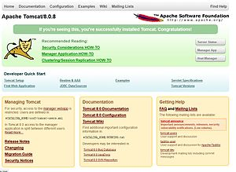

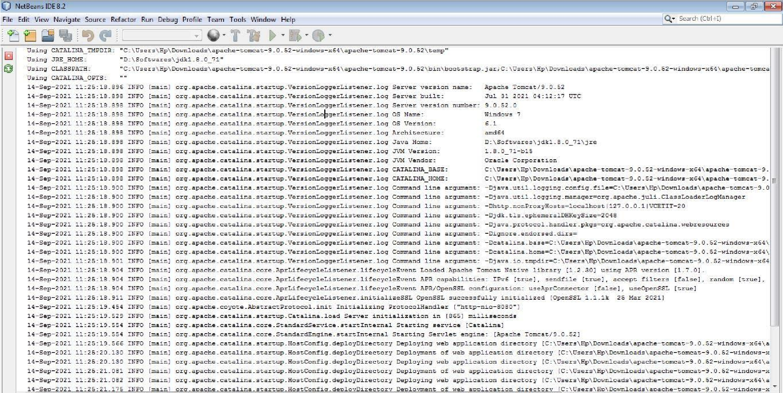

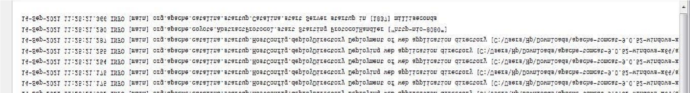

# RESULT

In this experiment, the installation of Apache Tomcat Server has been completed.